**2024 CITY OF NOME SPRING CLEANUP**

U-Call, We-Haul: **Tuesday May 28th - Friday May 31st**

Spring Cleanup Day: **Saturday June 1st**

# U-CALL, WE-HAUL

Tuesday May 28th-Friday May 31st Be sure to call **443-6663**

The City stops taking requests for U-Call, We-Haul at 12:00 noon on Friday, May 31st.

All items must be brought to the curb of the road and away from structures.

**NO: Drums of unknown chemical, Flammable products, wet paint, or batteries**

Refrigerators/Freezers: Each refrigerator/freezer must be empty and the door(s) removed.

**Vehicles:** Owner must sign a release form for all vehicles. Forms available at City Hall or website

Batteries:Vehicle batteries must be brought to Quality Auto and put in the battery stack.

*Batteries will not be picked-up by the City of Nome.*

*\*For City Residents Only * No Commercial Operations or Construction Jobs*

**MONOFILL** will be open for

**FREE DUMPING**

* May 28th-May 31st 11 am-7pm

*June 1st 9 am - 5pm

# CLEANUP - RAFFLE DAY!

Saturday June 1st

**FREE HOT DOGS & SODAS**

Noon – 4 p.m. at Old St. Joe’s

Prize Drawing at 4:10 p.m. at Old St. Joe’s

Collect 12 or more bags and get a chance to win one of five kids bicycles

(no repeat winners allowed)

**DUMP TRUCKS**

located at the following 3 sites on JUNE 1st, noon to 4pm:

*Icy View Fire Hall 401 Out of the Way

*Recycle Center Across from NAPA

*Rec Center Parking Lot

**Yellow Bags** are available during business hours Monday through Friday at:

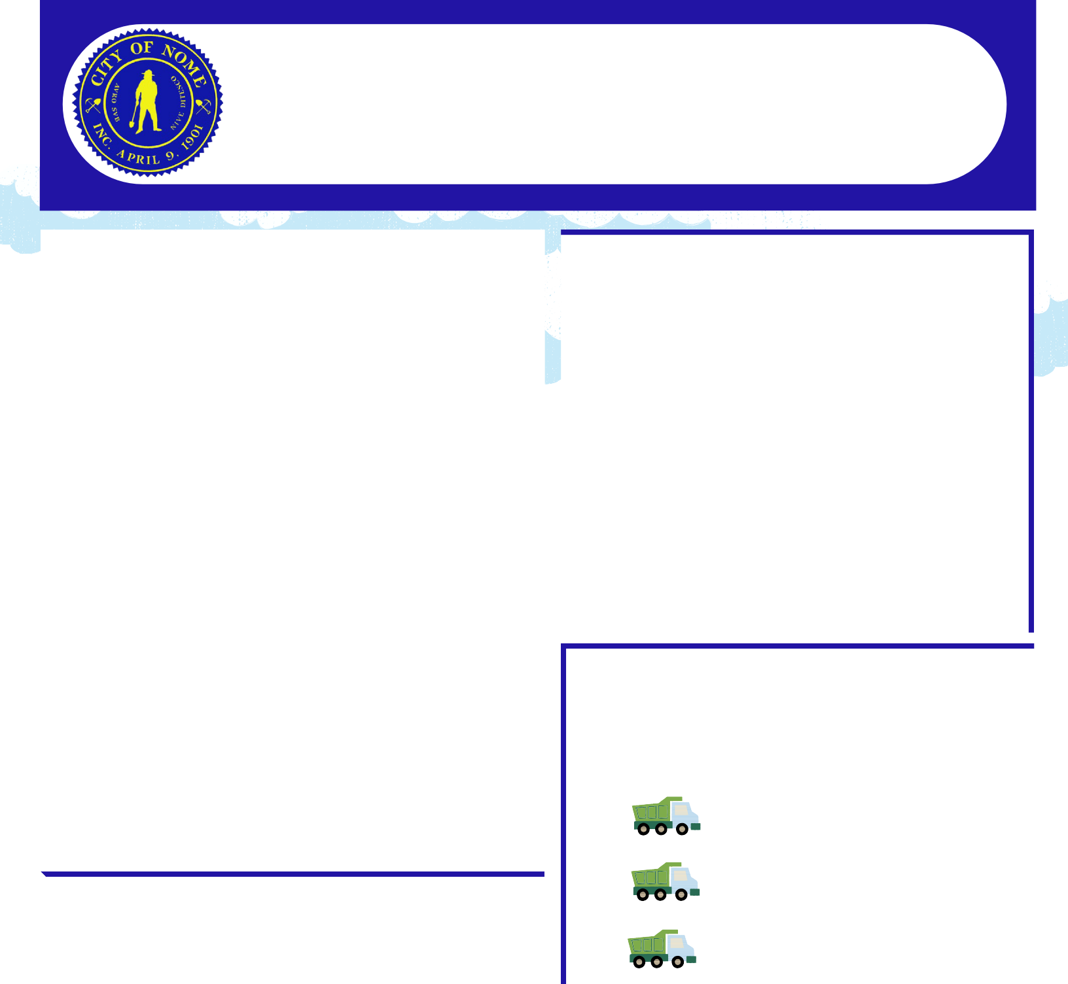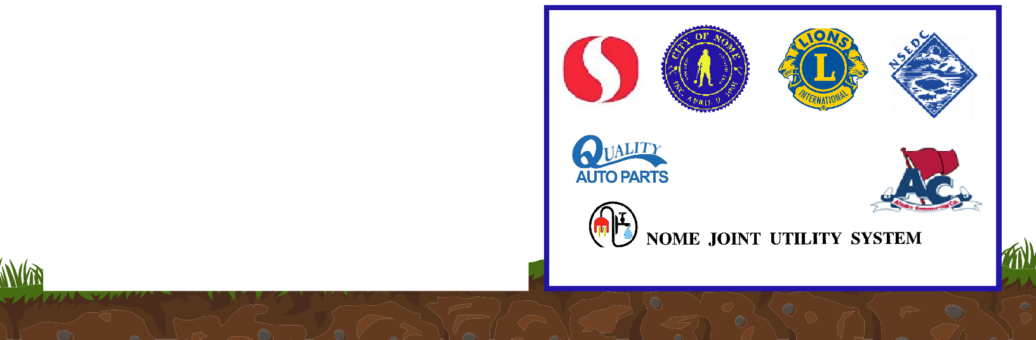

*City Hall

*Nome Rec Center

*Kegoayah Kozga Public Library

*Public Safety Building

Sponsored by: